A Model for Constructing the Geographical Profile of a Serial Killer
Table of Contents
- Introduction……………………………………………………………………………. 2
- Definitions, Assumptions, and Hypothesis……………………………………………. 3
- The Model for Building a Geographical Profile………………………………………. 4
  - Map/Coordinate Construction…………………………………………………….. 4
  - Scheme 1: Anchor/Buffer Zone Determination………………………………….... 7
  - Scheme 2: Decay/Growth Function………………………………………………. 8
- Testing Models…………………………………………………………………………11
- Strengths and Weakness of the Model………………………………………………… 14
- Recommendations……………………………………………………………………... 15
- Executive Summary…………………………………………………………………… 16
Works Cited……………………………………………………………………………. 18

I. Introduction
We constructed a cohesive model for generating a “geographical profile” that can be used to predict the location of a serial killer’s next crime based on the time intervals and locations of past crimes. The model provides a method for the police department to develop a map with a coordinate system to, 1) find the general location of the serial killer’s home, and 2) calculate the location of the killer’s next murder. The first step in utilizing the model involves constructing a geographical map that contains the crime site of every murder. This is accomplished by adding a computed distance to the northernmost, southernmost, easternmost, and westernmost crime sites in the region. The process forms a boundary in which the origin is in the southwestern most corner. After this step, the police department can convert each crime site into coordinate terms, and can plug these terms into the provided equation. Before the equation can provide significant data an anchor point must be determined. We calculated the anchor point in a similar fashion as that of the “circle hypothesis,” which was described by Canter in “Predicting Serial Killers’ Home Base Using a Decision Support System.” Canter claims that drawing a circle with a diameter equal to the max distance between the two furthest points yields an area containing 87% of the crime sites. In theory, the midpoint of these two furthest points will point the officers to the general area the criminal lives in.
Once the anchor is determined, the equation can then calculate values that correlate to an increasing likelihood – up until the distance becomes too far for the serial killer – and then a decreasing likelihood of a murder occurrence. This function uses a variable t that is defined as the time since the last kill, and a variable j which represents the serial killer’s cool down period. These variables should be estimated by the police department. Each Z value calculated with this equation has a deterministic probability associated with it.
II. Definitions, Assumptions, and Hypothesis
Definitions:
- Anchor point is the calculated coordinate of the midpoint of the furthest dumpsite coordinates.
- Border is the point at which growth of murder occurrence likelihood becomes decay; it is designated by a circle on the map.
- Boundary refers to the map’s outer limit. The boundary is calculated by the model.
- Buffer zone is an area in which a serial killer is unlikely to commit murder, so as to not create suspicion. It is also the area in which the serial killer is most likely to reside.
- Concentrated refers to killings perpetrated by one serial murderer in a given region.
- Cool down period refers to the time interval between the serial killer’s murders.
- Dispersed refers to killings perpetrated by one serial murderer in multiple regions.
- Dump site refers to the place where the killer disposes of the victim’s body
- Hot zone is the area where our geographical profile matches up with a provided psychological profile of the serial killer and indicates where the next murder will be committed.
- Premeditated murder refers to a murder done deliberately, or planned in advanced.
- Serial killer is defined as somebody who kills 4 or more people, who plans his attacks, and is motivated to kill.
Assumptions:
      - The serial killer lives in a stationary place.
      - The serial killer’s next kill will not be located in the same area as his last kill
      - The serial killer is less likely to commit crimes in the immediate vicinity of his home.
      - His victims do not escape (i.e. the bodies are found).
      - The serial killer has a constant cool down period between each kill or set of kills.
      - The murders are premeditated.
      - The murders are confined to a given boundary.

Rationale for Assumptions:
These assumptions are needed to create a model for the Visionary, Mission Oriented, Hedonistic Lust, and Hedonistic Comfort types of serial killers. All these types of serial killers are considered to be concentrated killers (Holmes). Therefore, our model works for four out of the six types of serial killers defined by Holmes in Serial Murder. Thus, there is a larger probability for the model to be suitable for a specific case.
Hypothesis:
We hypothesize that we are able to locate the area of the murderer’s residence given the location of the crime sites. Based on a calculated buffer zone, boundary, and the time and location of the last murder, we can predict a general area where the next kill will occur. The information on this area should be coupled with the murderer’s psychological profile provided by the local police agency in order to narrow down the search region.

III. The Model for Building a Geographical Profile
- Map/Coordinate Construction
Before we find an anchor point, or even develop an equation, we need to construct a map and a coordinate system. This allows the user to create a custom map tailored to their serial killer. Data on the location of past murders is needed to develop this map, so we assume that this information is available. The user can then find the furthest coordinates of the dump sites to the east, west, north, and south, by inspection. Then using a standard coordinate system, the user can calculate the horizontal x and vertical y distances between each of these dump sites, which can be drawn as horizontal and vertical lines through each of these coordinates. In order to capture every single dump site on the custom map, the model extends this area by an interval equal to half the distance of these horizontal and vertically drawn lines on all sides. Once the map is created, the origin will be located in the southwestern most point on the map, and the coordinates will always be positive. (See Figure 1).

Before any equation is presented the variables must be defined:
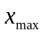 = the coordinate containing the highest value on the x-axis
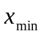 = the coordinate containing the lowest value on the x-axis
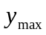= the coordinate containing the highest value on the y-axis
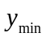= the coordinate containing the lowest value on the y-axis

The following equations extend the boundary on each side by a distance equal to half the distance of the max and min coordinates. The user will use these points to draw the horizontal/vertical lines denoting the boundary, thus creating our map.

The following equation gives a point on the horizontal line denoting the northern boundary:
(1) 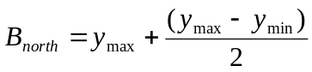
This following equation gives a point on the horizontal line denoting the southern boundary:
(2) 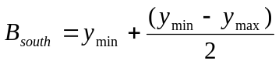
This following equation gives a point on the vertical line denoting the eastern boundary:
(3) 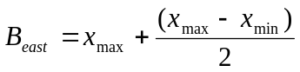
The following equation gives a point on the vertical line denoting the western boundary:
(4) 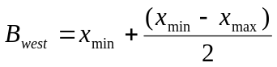
With these values the user can determine the northern, southern, eastern, and western boundaries on their map. The origin would be set in the southwestern most corner of this map. It should be made clear that this map will be based off of a geographical map and the units will be determined by the user of the model. The following figure (figure 1), depicts the process of the map creation using these formulas.
Figure 1
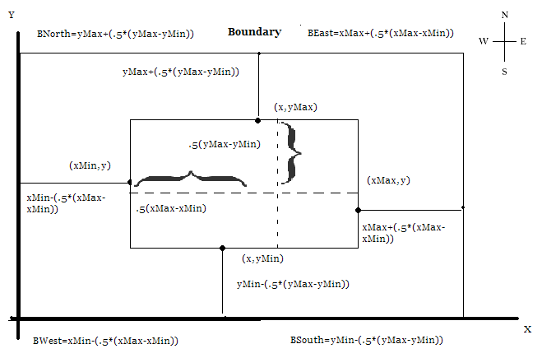

- Scheme 1: Anchor Point/Buffer Zone Determination
Determining the anchor point and buffer zone is an integral part to the model. After finding the anchor, the user will be pinpointing an area (buffer zone) on the map where the serial killer is most likely to reside. Once the anchor is determined, the buffer zone can be defined.
The theory behind finding the anchor point relies heavily on our assumptions. First, the serial killer must reside in a stationary place within the area designated by the map. Second, the serial killer’s next kill will not be located in the same area as his last kill. We will explain the logic with an example. Suppose the serial killer lives in a home located in a city. When he leaves his home to go hunt, the serial killer will mentally gauge how far away he is from his home with the goal of not attracting attention to his base location. Once he completes his task, he will dump the body in close proximity to the abduction, and at a distance beyond the buffer zone. The serial killer will then experience a cool down period. After the cool down period expires he will decide to hunt in area far removed from his last kill so as to appear random and to evade capture. It seems obvious as to why a serial killer would not return to a previous dump site; he would consider his last dump site an unsafe place to commit his crime. However, if a significant amount of time has passed, he may return to a previous dump site. By calculating the midpoint between the two furthest dump site coordinates on the map, we approximate the serial killer’s buffer zone. The buffer zone is calculated by taking a ball of a certain radius about the anchor where the radius is equal to the distance between the anchor and the serial killers closest kill.

Definition of variables and the resulting equations:
M - is defined as the space of the map
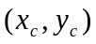 - is defined as the coordinates of the closest crime scene
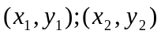 - is defined as the two coordinates with the greatest distance between them (found by taking Euclidean distance formula shown on the next page).

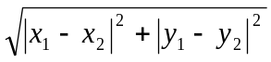
To find the anchor point, a, we apply the midpoint formula to
(1) 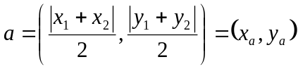
Our next step is to find a ball of radius r about the anchor point a, where
r = the radius equal to the distance between the coordinates of the closest crime scene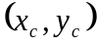 and the anchor, or rather, 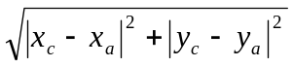.
(2) 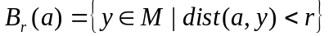
Again, this ball of radius r about the anchor point a will represent the buffer zone (can be seen in Figure 2 in the next section).

- Scheme 2: Decay/Growth Function to Determine Location
Now that we have developed the a map, anchor point, and buffer zone, we can move on to our second scheme: modeling a decay/growth function. The purpose of the function is to produce a value (which we refer to as a Z value) that corresponds with the likelihood of a murder to occur at a specific location. As the serial killer moves outside the buffer zone, the likelihood of murder must increase. Even though there is a chance the serial killer could kill within the buffer zone, the Z value within it will be noticeably smaller than outside of it. As soon as the serial killer exits his buffer zone, the Z values begin to increase considerably. The serial killer is only willing to travel a certain distance until it becomes inconvenient; this distance may be influenced by multiple reasons. The point at which the likelihood of a murder occurrence starts to decrease is what refer to as the border, which is defined as the average distance from the anchor to the crime sites. This implies that the serial killer is most likely to kill within a certain distance ε from the border. Therefore, the model incorporates both a growth function and a decay function. This interval combined with a psychological profile will provide the user with what we refer to as the hot zone.
The model incorporates two very important constants: the variable t- time since last kill, and the variable j- cool down period. Both variables are based on the times of the past crimes, but the j variable requires researching the intervals between each of the killer’s murders. For example, if a serial killer has a cool down period of 1 month, he will wait 1 month before he strikes again, that is, if he killed a person in January, he will wait until February to kill again. In reality, this may not always be the case. There could quite possibly be a serial killer who kills without a distinct pattern. The first variable, t, is far more direct and can be found by knowing time since the last kill. It seems reasonable to suggest that if the killer has a cool down period of 1 month, and he has not killed in 3 months, the likelihood of him killing soon is higher. Similarly, if a killer has a cool down period of 3 months, and he has not killed for only 1 month, the likelihood of him killing will be smaller. Also of note, if the time between the last kill and the present increases, the probability of him killing at all places increases. Depending on the cool down period, as time passes between the serial killer’s last kill and present day, the Z scores will increase.

Here are the variables:
h - the distance from the anchor; the Z score is dependent on this value.
the anchor and every kill site.
- a parameter based on the relationship between k and h. It takes on a value of 1 when h > k, and a value of 0 when h ≤ k.
t - time since last kill.
j - cool down period measured in months.
n - the total number of crime sites.
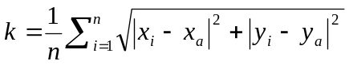 - This is the equation used to compute the average distance between the anchor point and all the crime sites.

We constructed a growth and decay function using these variables:
(1) 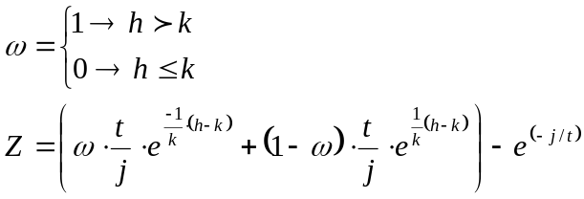
Up until the point where h = k, the growth function is in effect (since ω takes on a value of 0). After this point, in the area when h > k, the decay function then takes effect (since ω takes on a value of 1). An illustration of the function can be seen in the figure below (figure 2).
Figure 2
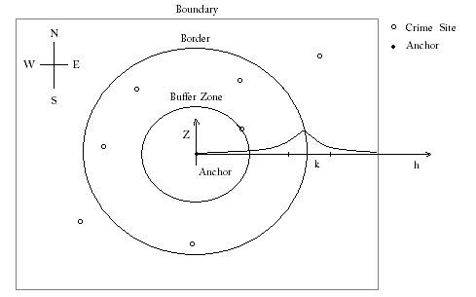

As seen in Figure 2, when the distance from the anchor increases, the serial killer’s Z score increases; thus, the likelihood of a murder increase.

IV. Testing the Model
We tested the model using Mathematica. Our algorithm randomly generates four geographical dump site coordinates. Then, after finding the anchor point, the algorithm calculates the k variable by taking the sum of the average Euclidean distances between the anchor point and the dump sites. With a given t, n, j, and a conditional ω, the algorithm can calculate a Z score.
As an example, we compiled a table of values using these constants: n = 4, j = 1, k = 22.4. This information tells us that our specific serial killer has murdered and dumped 4 people, has a cool down interval of 1 month, and has an average kill distance from the anchor of 22.4 miles. Table 1 shows how Z changes as h changes, given different values of t. One can see that as the t values increase – the time from last murder – the Z score changes significantly. Since the serial killer has a cool down period of 1 month, it is logical that if more than one month has transpired since his last kill, the likelihood of the next murder occurring increases. This logic is reflected in Table 1. Within Table 1 there are four different sub tables, denoted as a, b, c, and d. There are also corresponding graphs to each sub table on the following pages.

Table 1

Trials | t | h | k | j | Z
a.i | 1 | 1 | 22.4 | 1 | 0.02
a.ii | 1 | 4 | 22.4 | 1 | 0.07
a.iii | 1 | 8 | 22.4 | 1 | 0.16
a.iv | 1 | 12 | 22.4 | 1 | 0.26
a.v | 1 | 16 | 22.4 | 1 | 0.38
a.vi | 1 | 20 | 22.4 | 1 | 0.53
a.vii | 1 | 24 | 22.4 | 1 | 0.56
a.viii | 1 | 28 | 22.4 | 1 | 0.41
a.ix | 1 | 32 | 22.4 | 1 | 0.28
a.x | 1 | 36 | 22.4 | 1 | 0.18
a.xi | 1 | 40 | 22.4 | 1 | 0.09
b.i | 2 | 1 | 22.4 | 1 | 0.16
b.ii | 2 | 4 | 22.4 | 1 | 0.27
b.iii | 2 | 8 | 22.4 | 1 | 0.46
b.iv | 2 | 12 | 22.4 | 1 | 0.65
b.v | 2 | 16 | 22.4 | 1 | 0.90
b.vi | 2 | 20 | 22.4 | 1 | 1.19
b.vii | 2 | 24 | 22.4 | 1 | 1.26
b.viii | 2 | 28 | 22.4 | 1 | 0.95
b.ix | 2 | 32 | 22.4 | 1 | 0.70
b.x | 2 | 36 | 22.4 | 1 | 0.48
b.xi | 2 | 40 | 22.4 | 1 | 0.31

Trials | t | h | k | j | Z
c.i | 3 | 1 | 22.4 | 1 | 0.44
c.ii | 3 | 4 | 22.4 | 1 | 0.60
c.iii | 3 | 8 | 22.4 | 1 | 0.86
c.iv | 3 | 12 | 22.4 | 1 | 1.17
c.v | 3 | 16 | 22.4 | 1 | 1.54
c.vi | 3 | 20 | 22.4 | 1 | 1.98
c.vii | 3 | 24 | 22.4 | 1 | 2.08
c.viii | 3 | 28 | 22.4 | 1 | 1.62
c.ix | 3 | 32 | 22.4 | 1 | 1.24
c.x | 3 | 36 | 22.4 | 1 | 0.92
c.xi | 3 | 40 | 22.4 | 1 | 0.65
d.i | 4 | 1 | 22.4 | 1 | 0.78
d.ii | 4 | 4 | 22.4 | 1 | 0.98
d.iii | 4 | 8 | 22.4 | 1 | 1.32
d.iv | 4 | 12 | 22.4 | 1 | 1.74
d.v | 4 | 16 | 22.4 | 1 | 2.23
d.vi | 4 | 20 | 22.4 | 1 | 2.81
d.vii | 4 | 24 | 22.4 | 1 | 2.95
d.viii | 4 | 28 | 22.4 | 1 | 2.34
d.ix | 4 | 32 | 22.4 | 1 | 1.83
d.x | 4 | 36 | 22.4 | 1 | 1.40
d.xi | 4 | 40 | 22.4 | 1 | 1.04

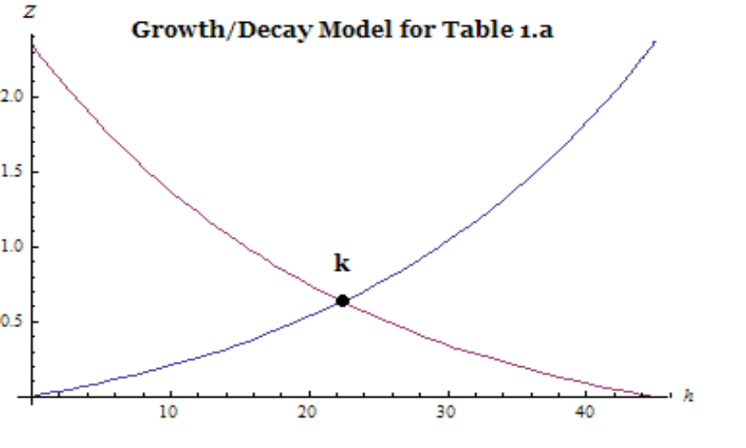

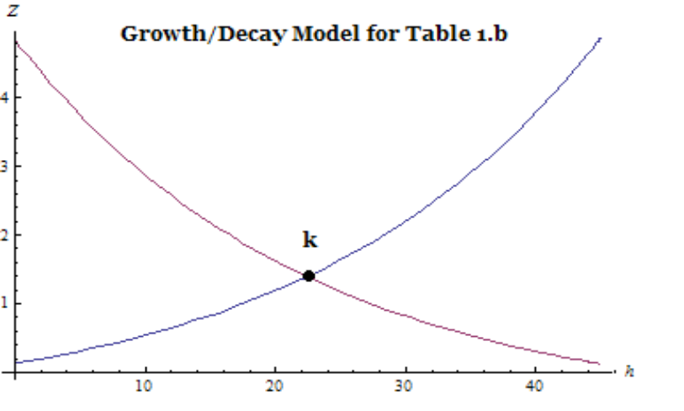

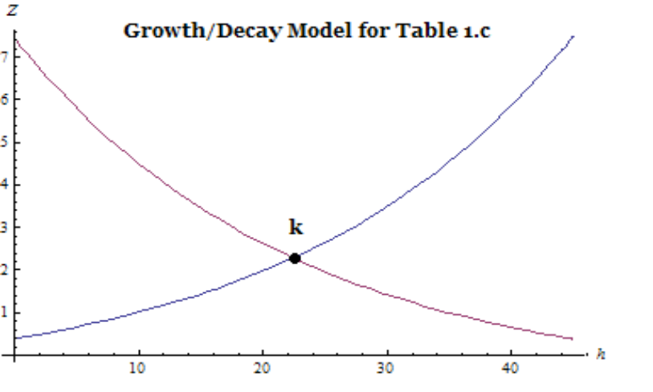
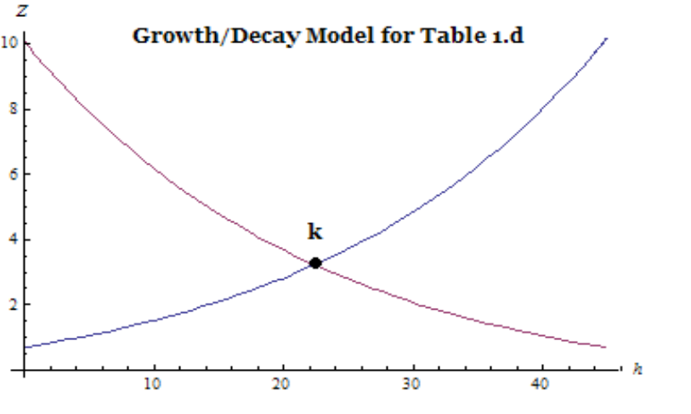

V. Strengths and Weaknesses of the Model
In developing this model, we created strengths and encountered weaknesses that are important to point out. If used appropriately along with traditional police methods, the model could successfully guide the authorities.
Strenths:
- Helps to narrow down the search area for a concentrated serial killer’s next target.
- Finds a general locatoin of the serial killer’s home.
- Calculates a value that corresponds to the likelihood of a murder occuring in a certain area based on time and locations of previous dump sites.
- Diminishes potential costs associated with investigation.
Weaknesses:
- Does not account for dispersed killers, e.g., mobile killers
- Only successful for serial killers who plan their attacks in advance.
- The model breaks down when the cool down period is not constant
- The Z value predicted by the decay/growth model would be more helpful when coupled with a probability function.

VI. Recommendations
We recommend using our model with the information the police department gathers. As Z increases beyond the buffer zone and reaches its maximum value k, the likelihood of a murder increases. So, we recommend looking in the annulus ranging from k-ε to k+ε, denoted by the dotted circles on Figure 3. The empirically determined constant ε is used to create a confidence interval about k.

Figure 3
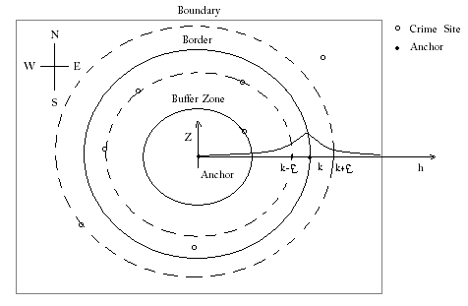
VII. Executive Summary
A series of at least four murders occur in a city within the United States of America. Profiling inputs are put together to determine the motive and the type of person who is responsible for the crimes, referred to as the serial killer. As data is being analyzed to create a criminal profile, models are generated to fit that specific situation. Our model comes to aid the local law enforcement in locating the serial killer. Also, it provides guidance towards a likely future crime site based on given information about time and location of the previous murders.
Our model is created using several key assumptions. First, the serial killer has a fixed operating base. Next, the killer’s next kill will not occur in the same area as the last kill and will not be performed close to his home. Finally, he commits first degree murder in an area confined to a given boundary, and has a constant cool down period between murders.
Used along with data from the crime scene, victimology, and forensic information, the model will first help police by providing an anchor point. The anchor point marks the center of a circular region where the suspected killer resides and allows authorities to start a search. It is to be noted that our model will only provide an accurate search region for the geographically stable killer. A different model would be appropriate for the apprehension of the mobile serial killer.
We created our model on the premise that the serial killer will commit murders in an area where he feels secure, that is, he will not kill close to his fixed operating base, thus creating a buffer zone. The fact that our killer is organized and deliberate with his kills allows us to use the hypothesis that by trying to be random, he will actually create a certain pattern. Typically, humans do not conform to the definition of “true randomness”. In a mathematical sense, random choices often contain clusters.
The mathematical model will allow the user to determine the likelihood of a murder occurring at a certain distance from the anchor based on location and time of the last murder. This will be a great asset that, used in conjunction with a criminal profile (finished, or in the making) can direct the search efforts of local authorities. While this model will predict with considerable accuracy, it is limited by the fact that it works for the serial killer who has constant cool down period after each murder. In reality, random psychological variables and pure opportunity might push a serial killer to commit a crime spontaneously. If this occurs multiple times, the exactness of our Z value (likelihood of a murder occurring in a given area) will decrease considerably.
While law enforcement will be directed to the correct regions, the search areas would be relatively large. This implies high costs and many work hours with potentially no immediate results. Therefore, it would be appropriate to use this tool along with psychological analysis to narrow down the range of possible locations. We would incorporate such details from the psychological analysis as: the type of person the serial killer hunted, where and how a victim would be abducted (if known), and the risk the serial killer takes in being at the abduction location.
In conclusion, the mathematical model we have created is useful in locating the serial killer’s fixed operating base and in determining the general area of the next crime. Along with the psychological profile, this model can whittle down the area where the search teams are sent to investigate.

Works Cited
Blanchard, Paul, Robert L. Devaney, and Glen R. Hall. Differential Equations. 3rd ed. Belmont: Brooks/Cole, 2006. Accessed February 19, 2010. <http://www.all-about-forensic-psychology.com/geographic-profiling.html.>
Canter, D. and Larkin, P. (1993). The Environmental Range of Serial Rapists. Journal of Environmental Psychology 13: 63-69.
Rossmo, D. Kim. Geographic Profiling. Boca Raton, Florida: CRC Press, 2000. Accessed electronically February 19, 2010. <http://books.google.com/books?id=YQlS59Pv35oC&dq=Rossmo,+D.+Kim.+Geographic+Profiling.&printsec=frontcover&source=bn&hl=en&ei=mzaCS8DfHIKcswOS1cGKBA&sa=X&oi=book_result&ct=result&resnum=4&ved=0CBUQ6AEwAw#v=onepage&q=&f=false>
Holmes, Ronald M. Serial murder. Newbury Park, Calif: Sage Publications, 1988. Print.
O'Leary, Mike The Mathematics of Geographic Profiling, Journal of Investigative Psychology and Offender Profiling, 6, pp. 253-265 (2009). Accessed electronically February 21, 2010. < http://pages.towson.edu/moleary/publications.html>
"Serial Killers." World of Forensic Science. Ed. K. Lee Lerner and Brenda Wilmoth Lerner. Gale Cengage, 2006. eNotes.com. 2006. 21 Feb, 2010. Accessed electronically February 20, 2010. <http://www.enotes.com/forensic-science/serial-killers>

